LAB 1,

INTRODUCTION TO JAVA AND ECLIPSE

JAVA FUNDAMENTALS

# Lab 1, Introduction to Java and Eclipse

## Objective

In this lab you will

* Create a Console program using the Eclipse IDE
* Run the program

## Overview

Eclipse is the development tool used by many Java developers and throughout this course. This lab will show you how to create and run a Java program.

## Step by step

### Creating a new Java application

1. Launch Eclipse and type C:\Labs as the location for your ‘workspace’.
2. Dismiss the Welcome window.
3. Choose menu option File > New > Java Project

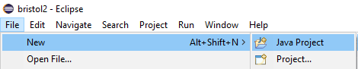

1. Type the following project name and location and then accept the other default settings::

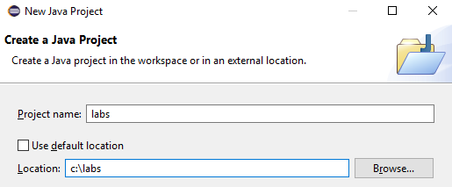

1. Click 'Finish'
2. Right click on the lab1 folder in your project explorer and then select

New > Package

name this package **lab01**

1. Right click on the **lab01** node and then select New > Class

Name this class **Program**



And make sure you select 

### Writing the Code

1. In the Program class's main method type the following:

public static void main(String[] args) { System.out.println("Hello, world!"); }

1. In the line below the System.out.println, type ‘sys’ and hit **Ctrl-Space** you'll find that *Content Assist* pops up a list of candidate.

Choose the entry **syso** ‘and then hit **Ctrl-Space.** The first entry in the context menu will type System.out.println.

Inside the parentheses type the String “My name is --” fill the -- with your name

Make sure you make full use of this time saving editor command.

### Building and running the program

1. Compiling the program is done by saving your code (Ctrl-s)
2. Press **Ctrl+F11** to run the program or click the green Run icon.

A Console window will become active at the bottom of Eclipse.   
Please view the output for the *println* messages.

** End **